

User’s Manual

Version 1.0

November 27, 2017

#### Presented by: DreamTeamCoding

Overview

## Dream Team coding has created something that will change college pre-registration forever. One of the most wide spread reason for college students not graduating on time is because they did not sign up for the correct classes. We at Dream Team Coding have created a web application called "A.P.O.S.", otherwise known as Automated Plan of Study. Using A.P.O.S will allow students to easily find their major and concentration. The student then chooses courses that they have already taken, or are currently taking (best to have the corresponding transcript handy). Once the all courses are chosen our software reads our data and compares it to our database of class and generates a list of classes you should take in the upcoming semester. The web application also features a save state, which allocates a passphrase for the user to save their progress and courses taken.

Features

Multiple Concentrations

Minimalistic Interface

Passphrase to save progress

#### Advantages

Ease of Access

Simplicity

Minimizes time with professors

Training

## Utilizing A.P.O.S.’s fast and user friendly application is as simple as tying your shoe. It takes less than 5 minutes to complete the process and have a full list of all the courses remaining in a user-friendly interface.

#### Step-By-Step

1. To begin, select from the dropdown menu and select your given concentration.

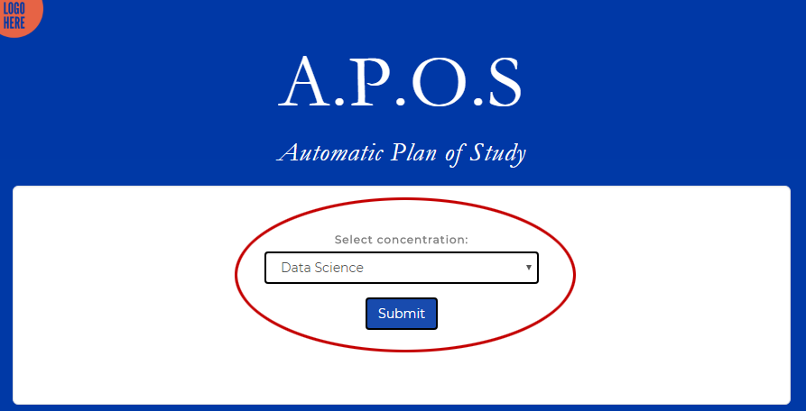

1. Once the concentration has been selected, press Submit.
2. Upon arriving at the courses page, select all of the courses that you have taken or are currently taking.
   1. 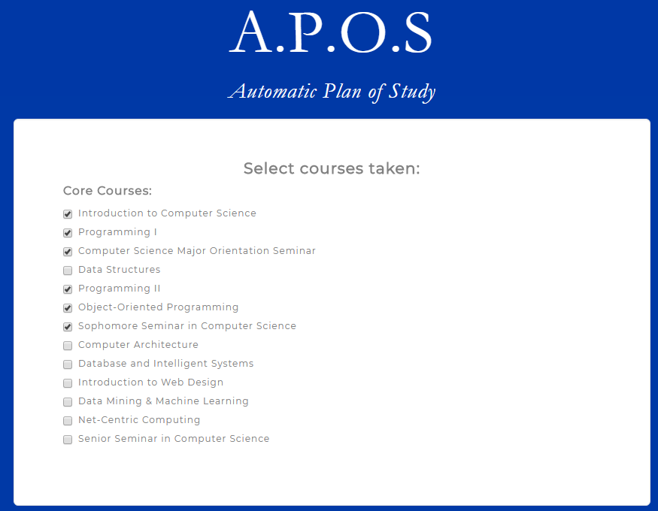The courses are separated by Major Requirements, Related Area Requirements, and Concentration Requirements.
3. Click Submit.
4. Await your results!

#### Results

The ending results should look something like this:

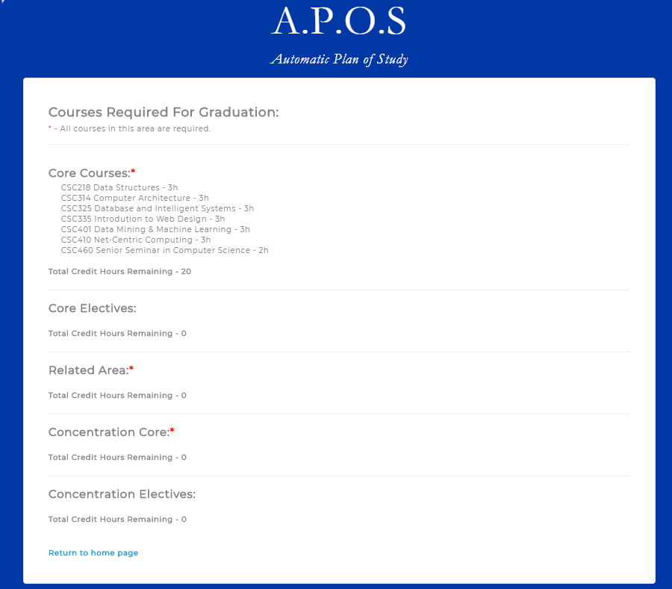

* Each individual section represents the area of your major concentration along with the courses remaining in that area.
* The sections marked with a red asterisk * indicate that *all* of the courses in that section must be taken.
* The sections that are not marked with a red asterisk are not required, and the user must only take courses totaling up to the total credit hours remaining in the corresponding section.

#### Returning User?

All users of A.P.O.S are given a unique **case-sensitive** passphrase which saves the users progress. Upon entering this passphrase on the homepage, the user will be redirected to the results page that they previously filled out.

